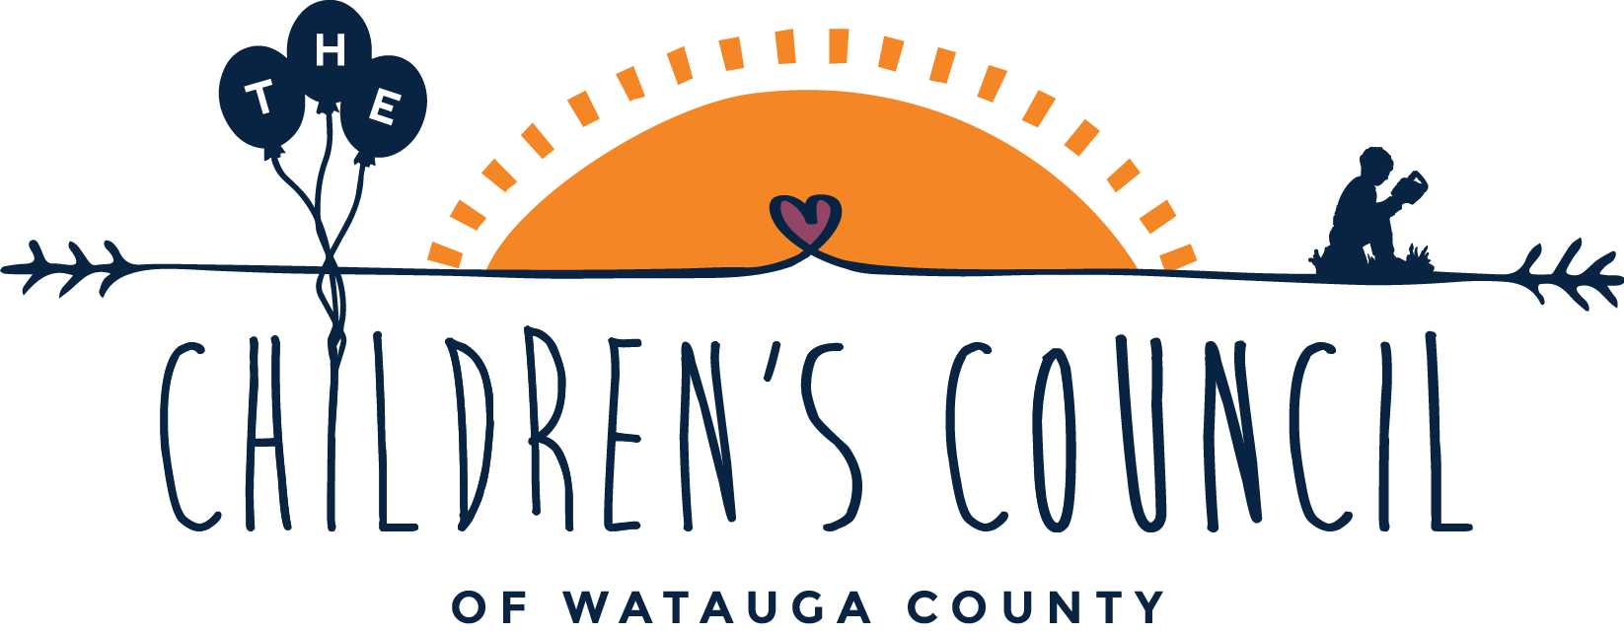

2015-2016 Watauga County NC Pre-Kindergarten Application
Parents/Families/Guardians must complete this application to apply for NC Pre-Kindergarten Program. You must use your child’s legal name that is on his/her birth certificate on this application. If you change your address or your phone number it is your responsibility to let us know. Please remember to sign this application!
ALL APPLICATIONS DUE BY MAY 15, 2015 & MUST BE RETURNED TO THE CHILDREN’S COUNCIL. ADDRESS: 225 Birch Street, Boone NC 28607 FAX: (828) 264-8008 PHONE: (828) 262-5425
To be eligible:
*Child must be four-years old on or before August 31st, 2015
*Child is from a family whose gross income is at or below 75% of the State Median Income (SMI).
*Children of certain military families are also eligible without regard to income.
*20% of age eligible children enrolled may have family incomes in excess of 75% SMI if they have documented risk factors in specific categories including:
Developmental Disability
Limited English Proficiency
Educational Need
Chronic Health Condition
Although a child may meet one or more eligibility factors, placement is not guaranteed in an NC Pre-K classroom.

Documents you are required to have with you when you return your application:
*2 proofs of residency (lease/utility bills/drivers’ license/cable bill/phone bill)
*Certified copy of the child’s birth certificate
*Proof of Gross Yearly Household Income including one or more of the following items:
(Copy of 2014 tax form 1040 line #37 or 1040A line #21, Pay Stubs, Award letters from Social Security Administration, Award letters from the Employment Security Commission, Employer statements, Business records for self-employed individuals, Signed statements when an individual claims to have no verifiable countable income)
*Medical information from a physician if your child has a chronic health condition
Fees | None, if your child qualifies for NC Pre-K
Notification of Acceptance | Families will notified by mail by early June, 2015 of their acceptance into the program (pending the approval of the North Carolina Budget)
Placement | Placements will be based on eligibility, priority of need(s), date that completed application was submitted and availability.
Health Assessment | Child’s Health Assessment is required before being enrolled or within 30 days after the child enters NC Pre-K Program
For more information: Hunter Varipapa at The Children’s Council (828) 262-5424 or via email: hunter@thechildrenscouncil.org
Watauga County NC Pre K Application 2015-2016

Full Legal Name of Child: _____________________________________________________________________

Gender: Male____ Female____

Child’s Date of Birth: _________/_________/_________

Child’s Race/Ethnicity (Check all that apply):
Asian _____
Black or African American _____
Hispanic _____
Native Hawaiian or Other Pacific Islander _____
Native American Indian or Alaska Native _____
White/European American _____

Is the child a North Carolina Resident: Yes _____ No _____

Application Date: _______________

Email where parent can be reach: ______________________________

County of Residence: _______________

Family’s Mailing Address: ____________________________________________________________________

Primary Phone Number: _______________ Alternate Phone Number: _______________

With whom does the child reside:
Mother only _____
Father only ______
Both Parents _____
Legal Custodian _____
Legal Guardian _____
Other, Specify _________________________________________

Does the child live with an adult blood relative or with a non-relative who has legal custody or guardianship: Yes _____ No _____

Number of family members (siblings, parents/guardians) who live in your home ______

Mother’s/Stepmother’s/Guardian’s Name: __________________________________________________
Mother’s Employment: (check all that apply)
Employed- Yes _____ No ______ Average Number of Hours Worked per Week- __________
Seeking employment- Yes _____ No ______
Attending secondary education- Yes _____ No ______
Attending high school/GED- Yes _____ No ______
Other employment: Yes _____ No ______ Explain: __________________________________________

Enter all income for the mother:
Current Yearly Wages BEFORE Taxes: __________
Alimony Yearly: __________
Child Support Yearly: __________
Workers Compensation: __________
Unemployment: ___________
SSI/TANF/Work$ First: __________

Father’s/Stepfather’s/Guardian’s Name: _________________________________________________
Father’s Employment: (check all that apply)
Employed- Yes _____ No ______ Average Number of Hours Worked per Week- __________
Seeking employment- Yes _____ No ______
Attending secondary education- Yes _____ No ______
Attending high school/GED- Yes _____ No ______
Other employment: Yes _____ No ______ Explain: __________________________________________

Enter all income for the father:
Current Yearly Wages BEFORE Taxes: __________
Alimony Yearly: __________
Child Support Yearly: __________
Workers Compensation: __________
Unemployment: ___________
SSI/TANF/Work$ First: __________

What is the primary language spoken in your home? English_____ Other___________
What is the primary language spoken by your child? English_____ Other___________

Does your child have a chronic health condition? Yes _____ No _____
Explain: ________________________________________________________________________________________
If yes, please attach a physician’s note explaining the condition(s) and any prescribed treatments/medications. This must be returned with your application.

Does your child have a developmental or educational need? Yes _____ No _____ Not Sure _____
Explain:
________________________________________________________________________________________

Is at least one parent or legal guardian of this child an active duty member of the military or was a parent or legal guardian of this child seriously injured or killed while on active duty: Yes _____ No _____

Prior Child Care Placement: (check one)
_____ Child has never been served in any preschool child care setting
_____ Child is currently unserved (at home now but may have previously been in child care or some other preschool program)
_____ Child currently attends childcare (please list the name of the program below)
Name of Childcare Program: ______________________________________________

Date of Child’s Last Health Assessment: (month, day, year) __________________________

Has your child had a Developmental Screening? No ____ Yes ____
If yes, include month, day, year __________________________

Has your child ever been referred for evaluation or identified for services for a special need?
Yes____ No_____
If yes, include month, day, year of referral date: __________________________
If yes, what was the decision from the disability evaluation for your child?
No Disability Identified ____
Evaluation Decision in Process _____
One or More Disabilities Identified _____
Do not know _____

Name(s) of identified disability/delay: _____________________________________________

Does your child have a current Individualized Education Plan (IEP)? Yes____ No ____

Watauga County Schools serves identified Pre-K age students with disabilities by having service providers (i.e., teachers and therapists) come to the site where the student is attending a Pre-K class. Watauga County Schools will make every effort to place a student with a disability, that is eligible to enroll in one of our WCS NC Pre-K classrooms, at the WCS NC Pre-K site in or closest to their school attendance zone. Due to the child's individual educational needs though, and in accordance with federal and state law, it may be necessary for the district to place the student in a different WCS NC Pre- K class outside of their attendance zone in order to provide a free, appropriate public education as required by that student's Individualized Education Program (IEP). In this case, the child's IEP team, of which the parent is a member, will convene to discuss this recommendation.

Has your child been referred for services related to disability? Yes _____ No _____

Is your child receiving services related to disability? Yes _____ No _____
If yes, please specify type of disability services ___________________________________________________
Do you have any concerns with your child’s development? Yes _____ No _____
If yes, please explain your concerns ____________________________________________________________
If you have concerns with your child’s development, would you like for a representative from The Children’s Council to contact you about scheduling a free developmental screening for your child? Yes _____ No _____

2015-2016 Pre-Kindergarten Classroom Locations (subject to change) *Transportation is only provided to students who attend a pre-k classroom in their school district.
Cove Creek Elementary School
Green Valley Elementary School
Hardin Park Elementary School
The Lucy Brock Collaborative Classroom at Parkway Elementary School
Valle Crucis Elementary School

Please list below your preferred pre-k site(s) in order of preference:
- ____________________________________________________________
- ____________________________________________________________
- ____________________________________________________________
- ____________________________________________________________
I certify that all the information on this entire application is true to the best of my knowledge. I understand I am responsible for calling The Children’s Council of Watauga County, 828-262- 5424, with any changes to information on this application. I give my permission for the information on this application and any other documentation that I submit with this application to be viewed by The Children’s Council of Watauga County’s staff, Department of Child Development and Early Education, Department of Social Services, Watauga County School’s staff and others as necessary to verify accuracy. I understand that knowingly providing inaccurate information will result in this application being rejected.
_____________________________________________________________ __________________________
Signature of Parent/Guardian Date

To be completed by The Children’s Council of Watauga County Staff Member:

Date of Submission of Completed Application: _____________________

Name of Staff Who Reviewed Application: _________________________

----------------------------------------------------------------------------------------------------------------------------
To be completed by The Children’s Council of Watauga County Staff Member
Receipt of Completed Application (please keep for your records and proof of submission):

Parent/Guardian’s Name(s) _____________________________________
Child’s Name_________________________________________________
Date of Submission of Completed Application: ___________________
Printed Name and Signature of Staff Who Reviewed Application:
__________________________________________________________________________

